Results

Single cell RNA-sequencing data
To prolife cell-type composition of B6.wt, B6.mdx, D2.wt and D2.mdx muscles, we performed single cell RNA-sequencing (sc RNAseq) on freshly FACS (fluorescence-activated cell sorting)-isolated cells from gastrocnemius muscles dissected from 6-week-old male mice for each genotype.
Filtration control, doublet and ambient RNA removal, gene features, (average number of genes expressed per cell)
Data demultiplexed in fastq format was checked with fastqc and fastq_screen to control quality sequencing. Sequencing reads were processed with STAR (v.2.7.11b) to align and count data for each sample with conservation of rRNA during process. Genome and transcriptome used is GRCm39.111 from Ensembl Database. We counts pre-mRNA overlap gene loci included both exonic and intronic reads where priority is purely exonic alignment (GeneFull_ExonOverIntron option) and spiced, unspliced and ambiguous counts per cell similar to the velocyto.py (Velocyto option). We used output reads statistics (--soloCellReadStats Standard) for each barcode to build our filter thresholds by sample. First, we filtered only barcode where genomeU metrics > 1 and nGenesUnique => 200. Second, we determined the different elbow points along different metrics density by sample with akmedois::elbow_point R function and we selected the minimum of value when the point is tagged “minimum”. At final, tab.1 summarize these thresholds metrics by sample :
 | genomeU* | featureU** | % mitochondrial (mito/genomeU) | ReadsTotal (genomeU/cbPerfect***)
D2-mdx | 14905 | 13024.14 | 12 | 0.39
D2-wt | 66624.09 | 56222.4 | 15 | 0.23
B6-mdx | 15826.45 | 14316.92 | 13 | 0.15
B6-wt | 1159.94 | 12156.24 | 14 | 0.55

* : number of reads mapping to one locus in the genome. ** : number of reads mapping to one feature. *** : number of perfect match on cell barcode.
Third, we determined outliers candidates when used classical outlier detection with this formula
${readsTotal}_{barcode}<\left[Q1\left({readsTotal}_{barcode}\right)−1.5∗IQR\left({readsTotal}_{barcode}\right)\right]$
or ${readsTotal}_{barcode}>\left[Q3\left({readsTotal}_{barcode}\right)+1.5xIQR\left({readsTotal}_{barcode}\right)\right]$
Fourth, we calculated the nuclear fraction (NF) ratio (intronic/exonic) to conserve any barcode with NF>0. Fifth, we powered the percentage of any biotype for each barcode. To identify a “closed” model of integrity cell, we build a covariance matrix with nCount_RNA, nFeature_RNA, genomeU, cbPerfect, mito and percentage of protein coding. Then, we calculated a mahalanobis distance of it and determined outliers barcode when distance pass the pvalue of Chi-square test of independence (x² depending of sample with 7 degrees of freedom). Sixth, we determined Doublet barcode with scDblFinder R packages on cluster-based approach and dbr=0.1. Seventh, we selected any features where mean(count _{sample})_{feature} > 0.1.
In total, 1,297 cells and 17227 features in B6.wt, 6,238 cells and 25779 features in B6.mdx, 1,476 cells and 21026 features in D2.wt and 2,164 cells and 21045 features in D2.mdx were sequenced and used for further analysis.
The downstream treatment for analysis separatly and integrativly after filtering used is SCTransform with glmGamPoi method and a regression of percentage of mitochrondrial, PCA on SCT assay, (s)KNN graph build on pca reduction matrix with a dimensions depending of sample (we selected the last elbow point where cumulative sums of percentage Standard Deviation > 90% and the n+1 dimension not exceed < 1% supplementary), we used Leiden Clustering with igraph method.
For integrative analysis, we build a “group” variable depending of name sample, condition and lineage. We used merge dataset and used JoinLayers from Seurat v5, split merge dataset in function of group value of interest. We performed merged object with the same process before. Before (s)KNN graph building, we used IntegrateLayers with HarmonyIntegration of SCT assay. We build (s)KNN graph on harmony reduction matrix with all dimensions calculated (50). We used Leiden Clustering with igraph method.
For the visualization, we used UMAP as 2 different resolution : 0.2 and 0.8. We used also FFT-accelerated Interpolation-based t-SNE (FItSNE) with this parameters : a modification of initialization (first and second Harmony dimensions are divided by standard deviation of first Harmony dimension multiplied by 0.0001), perplexity_list used is a list starting 30 to nCells_{integrated dataset}/100) and learning rate = nCells_{integrated dataset} / 12, all harmony dimensions used and 1000 iterations to run.
To determine clusters, we compared 2 methodologies :
- manual based on know genes with a strong association with a cell identity
- projection of mkellar, at al. as reference dataset with used FindTransferAnchors and TransferData R function from Seurat.
Biomarkers are identified after PrepSCTFindMarkers on SCT assay and performed with FindAllMarkers with MAST test. We filtered filtered biomarkers to conserve only features |pct.1_{feature/cluster} – pct.2_{feature/cluster} | > 0.2 and p-adj < 0.05. We selected a top5 on each cluster found and sign of log2FC.
CellCycle are performed by tricycle R package.
Pathway annotation are calculated after downloading gmt files from msigdb and raffine geneset depending of dataset tested (we conserve only geneset where 75% of genes are common between geneset and dataset). We calculated a UCell Score with AddModuleScore_Ucell on SCT assay and we determined a smooth signature scores by kNN from Ucell R package.
Integrative analysis of the 4 datasets identified 18 Seurat clusters (Figure 1a). To define each cluster, we first analysed the expression of canonical cell type markers that highlighted 7 hypergroups (Figures 1c, 2a), defined as:
- the muscle stem cells (MuSCs) that include quiescent and proliferating muscle stem cells (MuSCs, Pax7+, clusters 4 and 13) and lineage-committed cells (Myog+, cluster 14),
- the fibro-adipogenic progenitors (FAPs, Pdgfra+, Mme+, clusters 7 and 5),
- the endothelial cells (ECs, Tie1+, Flt1+, clusters 1, 7, 12, 17, and 18),
- the mural cells including the smooth muscle cells (cluster 16) and the pericytes (cluster 11),
- the immune cells (Cd74+, Ptprc+, clusters 2, 5, 9 and 10),
- the tenocytes (cluster 6, Scx+, Tnmd+),
- and the neural cells (Schwann cells, cluster 14, Mpz+, Ajap1+).
Overall, cells for each genotype distribute homogeneously in each hypergroup. Consistent with the inflammation induced by a dystrophic environment, both B6.mdx and D2.mdx muscles exhibit increased proportions of immune cells.

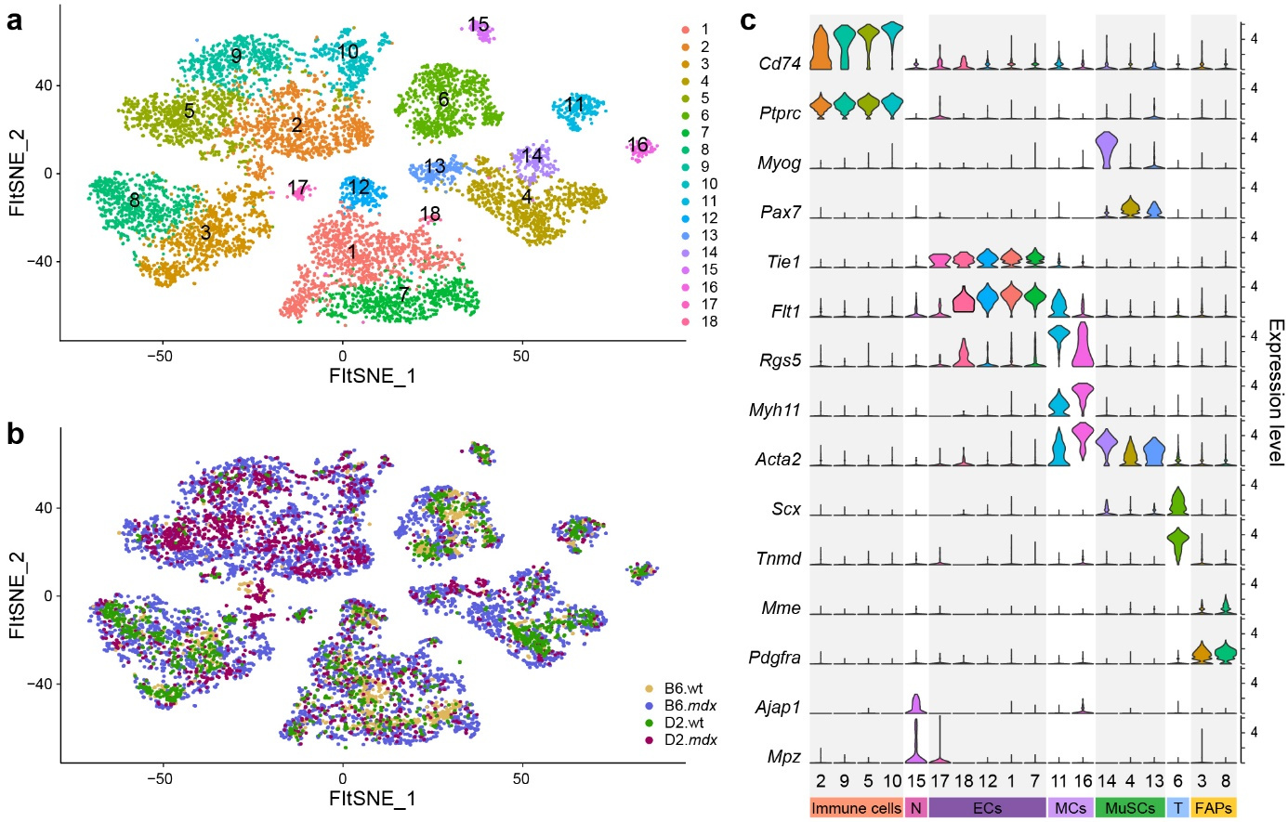
Figure 1: Integration of the 4 single-cell RNAseq datasets. a) Unbiaised clustering of the integrated scRNAseq data represented on FFT-accelerated Interpolation-based t-SNE (FIt-SNE). b) Fit-SNE representation of integrated scRNAseq data where cells are colored by genotypes (yellow, B6.wt; blue, B6.mdx; green, D2.wt; magenta, D2.mdx). c) Violin plots showing the expression of selected canonical genes within each cluster. Cd74 and Ptprc identify the immune cells. Myogenin (Myog) and Pax7 identify the muscle stem cells (MuSCs). Tie1 and FLt1 identify the endothelial cells (ECs). Myh11 and Acta2 identify the mural cells (MCs). Scx and Tnmd identify the tenocytes. Mme and Pdgfra identify the fibro-adipogenic progenitors (FAPs). Ajap1 and Mpz identify neural cells (N).

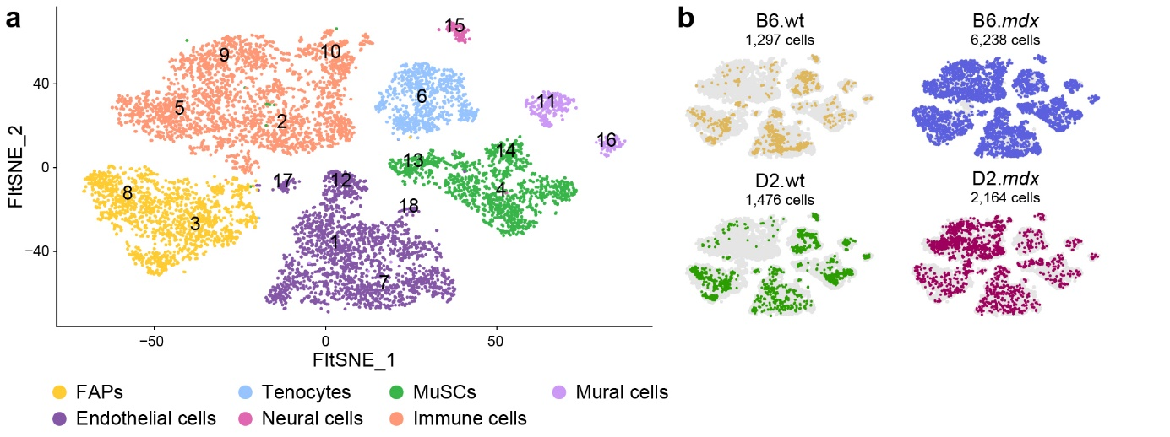
Figure 2: Integration of the 4 single-cell RNAseq datasets identifies 7 main cell types (hypergroups). a) Fit-SNE representation of integrated scRNAseq data. Cells are colored by main types (yellow, FAPs; orange, immune cells; dark purple, endothelial cells; green, muscle stem cells; blue, tenocytes; pink, neural cells; light purple, mural cells) that are defined by selected canonical gene expression. b) Cell distribution for each dataset. Each genotype (wt or mdx) is presented side-by-side for the B6 (top panel) and D2 (lower panel) mouse strains.

After characterization of different hypergroup of lineage D2/A2 mdx-wt, we identified 4 hypergroups contains a more one cluster found (= MuSCs, Immune Cells, Endothelial Cells and FAPs) and 3 hypergroups contains only cluster found ( = singleton, Tenocytes, Mural Cells and Neural Cells).
We created 4 subdatasets composed :
Groups | Hypergroup | Clusters
Non-singleton | Immune Cells | 1, 4, 7, 10 & 15
Non-singleton | FAPs | 3 & 11
Non-singleton | MuSCs | 5 & 9
Non-singleton | Endothelial Cells | 8 & 14
Singleton | Neural Cells | 13
Singleton | Tenocytes | 6
Singleton | Mural Cells | 8

For each subdataset, we split data by sample, we reduced processing information (loss SCT assay, kNN graph, clustering, etc). For each sample, we merged subdataset samples into a same object. We performed by SCTransform-Harmony integration method from Seurat v5. We build a (s)KNN-graph on all Harmony dimensions and applied Leiden clustering on it. We processing 2 resolutions : large and low levels.
Subdataset | Large levels resolution | Low levels resolutions
Immune Cells | 0.2 | 0.4
FAPs | 0.2 | 0.8
MuSCs | 0.2 | 0.8
Endothelial Cells | 0.1 | 0.4

With this approach, we identified an organisation of cells into 3 levels : hypergroup → large subcluster → low subcluster.
Exception for Immune subdataset, DEG analysis shows cluster 1, 2 and 3 at resolution=0.2 as very similar and we managed to group these cluster in one. Cluster 4 and 5 are singletons.

Spatial RNA-sequencing analysis
Data demultiplexed in fastq format was checked with fastqc and fastq_screen to control quality sequencing. Sequencing reads were processed with SpaceRanger (v.2.1.1) to align and count data for each sample. Genome and transcriptome used is refdata-gex-mm10-2020-A from 10x Genomics. Images used in tiff format from […].
Data are imported with Voyager (v.1.6.0) in SFE object and we followed advanced segmentation protocole to select good spots (used high resolution images, passed a grayscale thresholds (< 0.8 for D2mdx_rep2 and B6mdx_rep2 ; < 0.7 for D2mdx_rep1 and B6mdx_rep1), passed a detection mask, calculate area spot in tissue, exclude any spot which didn’t coverage tissue and nFeature (as named detected metric) <= 130).
Each slide are analyzed separatly for the downstream analysis. We log-transformed normalized expressions values, we modeled the per-gene variance and selected top2000 high variance genes, we performed PCA on theses genes in 30 components, we calculated Moran Index on theses genes. In parallel, we performed SpatialPCA (from v.1.3.0) on gene expression count matrix (no transformation) with gene.type=”spatial”, sparkversion=”spark”, gene.number=2000, min.loctions=0 and min.features=0 ; calculated kernel matrix from spatial locations (kerneltype=”gaussian”, bandwithtype=”SJ”) ; estimated loading matrix on 50 components and calculated Spatial Principal Component (as named latent factor matrix Z).
We built a Seurat Object for each slide. After importing, we performed SCTransform on spatial assay with variable.features.rv.th=1.3 and method=”glmGamPoi” ; we performed PCA. We imported SpatialPCA dimension reduction (SPCA). We estimated PCs using as 8 for PCA and 10 for SPCA for each slide. We computed shared nearest-neighbor graph with PCA and SPCA. We determined non-spatial clusters (from PCA snn graph) and spatial clusters (from SPCA snn graph) with Leiden algorithm in many resolutions.

Deconvolution of spatial RNA-sequencing data
For the deconvolute each level of single cell experiment to spatial transcriptomic experiment, we used BayesPrism (v.2.2.2) and his extension InstaPrism (v.0.1.6).
We follow standard processing : prepare input reference dataset from SCT assay and count layer, select type labels as hypergroup levels and select state labels as subclustering levels ; run deconvolution on spatial assay for each slide.
To show the cell type composition at each spot, we developed a custom script. After extraction of images and spots locations ; and alignment of data, we used deconvolute results :
- with Myofibers deconvolute score and others hypergroup
- with subcluster Pax7+, Myog+ deconvolute score (subcluster_MuSCs_3 in B6 lineage ; subcluster_MuSCs_1 in D2 lineage) and others hypergroup
In parallele, we performed Getis-Ord Gi* metric to find hotspots and coldspots of a feature or deconvolute score in space. After importing deconvolute scores in SFE object, we use colDataUnivariate function from Voyager R package with type=”localG_perm” on a spatial neighborhood graph in style=”B”. We used plotLocalResult R function to show hotspots (high values of Gi*) and coldspots (low values of Gi*). To confirme hotspots and coldspots, we performed pseudo-p-values. We changed lowest color to be the same as no-values or lowest coldspots.

Pseudotime

Methods

Mouse lines
D2.B10 (DBA/2-congenic) Dmd^{mdx} mouse
6-week-old
male
All mice were maintained in a pathogen-free animal facility under standard 12h light/12h dark cycle at 21°C with access to standard chow and water ad libitum. All experiments were performed in accordance with protocols approved by the ethical committee (blablabla).

Single-cell RNA-sequencing library preparation

Spatial RNA-sequencing library preparation
Gastrocnemius muscle from 6-week-old D2.B10 (DBA/2-congenic) Dmd^{mdx} mouse was isolated, embedded in OCT and flash-frozen in liquid nitrogen-cooled isopentane. Embedded muscle was transversely sectioned at 10 µm thickness. 10 µm tissue section was fixed with methanol, stained by hematoxylin and eosin (H&E) and imaged using the Zeiss Axio Scan.Z1 slide scanner. Section was then permeabilized for 18 min (optimal permeabilization time was determined using the 10x Genomics Visium Tissue Optimization Kit). Spatially tagged cDNA libraries were generated following the Visium Spatial Gene Expression 3′ Library Construction Kit (10X Genomics). cDNA library was sequenced in paired-end on an Illumina NextSeq 500. Frames around the capture area on the Visium slide were aligned manually and spots covering the tissue were selected using Loupe Browser software (10X Genomics). Sequencing data were then aligned to the mouse reference genome (mm10) using the spaceranger v1.0.0 pipeline to generate a feature-by-spot-barcode expression matrix (10X Genomics).

